A test for simple causality in time series data

Abstract:
This paper presents a very simple test for detecting causality in times series data.

Keywords: RQA, recurrence analysis, consecutive recurrence, times series analysis, causality test

Although test for causality is based on existing methods (recurrence analysis), its radial consecutive recurrence plot is a new way of presenting in an unambiguous way the difference between simple causal and random processes. This methods will be illustrated through implementation on two time series, chaos and bios generated with recursion A(t+1) = A(t) + g*sin(A(t)), where g = 4.5 for chaos, and g = 4.7 for bios. A(1) = 1 for both series.
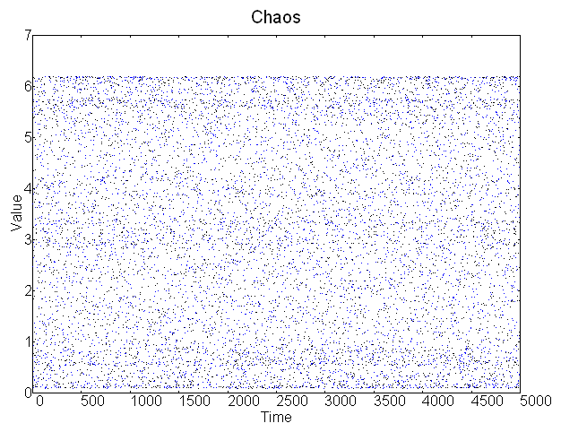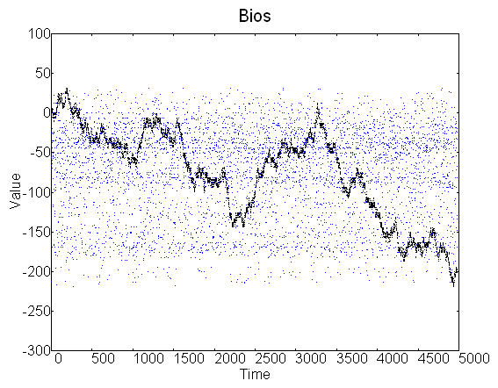
Time series (black color) and shuffled copy (blue color) of chaos (left) and bios (right).
Simple form of causality can be detected based on expectation that similar values (causes) will have similar consecutive values (effects). Of course, most time series do not represent isolated systems or processes, but are shaped by external factors.

Causality of the series may be detected with the recurrence method in the following manner. Given the series of numbers X(1), X(2), X(3), …, X(N), arbitrary radius r and indexes i and j such that i, j in (1, 2,…, N), if |X(i) – X(j)| < r, repetition is counted. For every such repetition, if |(X(i+1) – X(j+1))| < r, the consecutive repetition is counted. Ratio of consecutive repetition over repetition is a measure of causality.

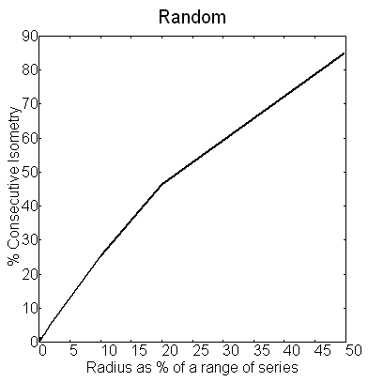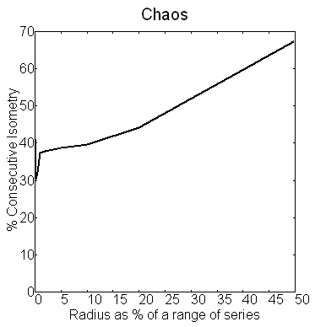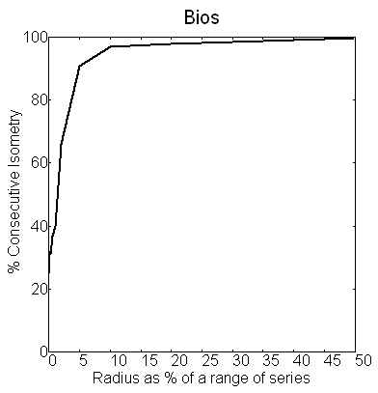
Figure: Percent consecutive recurrence (y axis) as a function of radius (x axis) of different time series. Note initial jump in causal series generated with mathematical recursion.
Recurrence plots for all three series resemble the plot of random series on the left. When radius is 0 there are no recurrences. As it increases, percent recurrences increases.
For testing series for causality, radial plots are used, where repetitions are tested for different radius values. For very small radii, there will be no consecutive repetitions in most of the series, except trivial exceptions like steady states, periodicities, etc. As radius increases, for random processes, there will be gradual increase in consecutive repetition, while for causal processes, there will be sudden initial increase, and then increase will become gradual. Since in causal processes, similar causes produce similar effects, as soon as there are recurrent (similar) values, they will have recurrent (similar) consecutive values.

Python code and additional explanation can be found here:
http://www.inverudio.com/programs/BiosAnalyzer/pythonsourcecode.html

This is the main idea from the paper I wrote that was rejected in part due to lack of probability or statistical tests, lack of definition of 'measure', etc. Since I won't be submitting it again, I put it here. If you have more mathematical and statistical skills than me (know how to define a measure, do statistics etc.), and if you find this idea useful, you are welcome to use and improve it and do whatever you want with it.

To quote part of review:
Now causality is a word that means many things to many people. While the MS has some nice, interesting graphs, I am not convinced that what the authors are showing is causality in any really interesting definition of the word - a causes b because a affects the universe in such a way that b is then more or less likely to happen. There is some mathematical analogue of this idea buried in the python code but it seems rather remote and abstract. Perhaps even circular - "any time series our algorithm turns into certain shaped plots must have arisen because of a phenomenon we call causality".

My thought on how to test this idea further:

One possible thing to explore is to find correlations of different time series which 'score' well or poorly on existing tests for causality
(http://www.google.com/search?num=100&hl=en&q=deterministic+OR+determinism+OR+causal+OR+causality+%22time+series%22&btnG=Search), and to compare those results with results obtained with this test. It may turn out that this test is more useful (computation time wise) than some other existing tests. If you have on your computer many such 'causal' and 'random' series for which you know results from existing causality tests, you can do this analysis within minutes with the program that I wrote:

http://www.inverudio.com/programs/BiosAnalyzer/BiosAnalyzer.php

